PYTHON

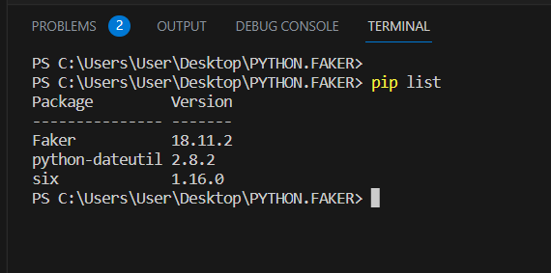

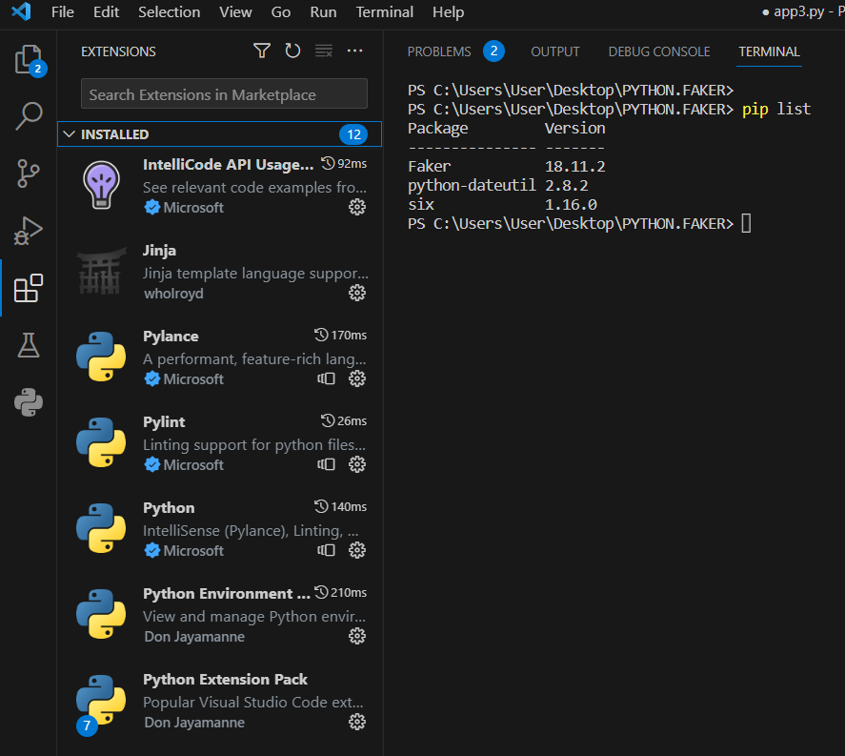

from faker import Faker

fake=Faker('es_ES')

for n in range(1,101):

print("insert into cliente values", "(",n,",","'",fake.first_name(),"',","'",fake.last_name(),"',","'",fake.address(),"',","'",fake.phone_number(),"',","'",fake.unique.email(),"');")

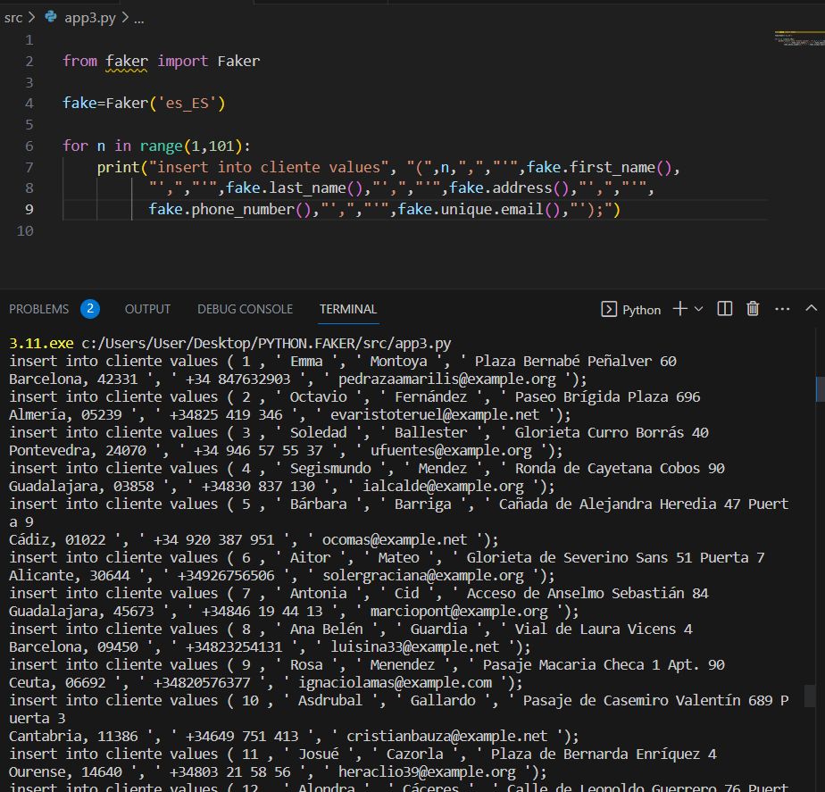

insert into cliente values ( 1 , ' Emma ', ' Montoya ', ' Plaza Bernabé Peñalver 60

Barcelona, 42331 ', ' +34 847632903 ', ' [pedrazaamarilis@example.org](mailto:pedrazaamarilis@example.org) ');

insert into cliente values ( 2 , ' Octavio ', ' Fernández ', ' Paseo Brígida Plaza 696

Almería, 05239 ', ' +34825 419 346 ', ' [evaristoteruel@example.net](mailto:evaristoteruel@example.net) ');

insert into cliente values ( 3 , ' Soledad ', ' Ballester ', ' Glorieta Curro Borrás 40

Pontevedra, 24070 ', ' +34 946 57 55 37 ', ' [ufuentes@example.org](mailto:ufuentes@example.org) ');

insert into cliente values ( 4 , ' Segismundo ', ' Mendez ', ' Ronda de Cayetana Cobos 90

Guadalajara, 03858 ', ' +34830 837 130 ', ' [ialcalde@example.org](mailto:ialcalde@example.org) ');

insert into cliente values ( 5 , ' Bárbara ', ' Barriga ', ' Cañada de Alejandra Heredia 47 Puerta 9

Cádiz, 01022 ', ' +34 920 387 951 ', ' [ocomas@example.net](mailto:ocomas@example.net) ');

insert into cliente values ( 6 , ' Aitor ', ' Mateo ', ' Glorieta de Severino Sans 51 Puerta 7

Alicante, 30644 ', ' +34926756506 ', ' [solergraciana@example.org](mailto:solergraciana@example.org) ');

insert into cliente values ( 7 , ' Antonia ', ' Cid ', ' Acceso de Anselmo Sebastián 84

Guadalajara, 45673 ', ' +34846 19 44 13 ', ' [marciopont@example.org](mailto:marciopont@example.org) ');

insert into cliente values ( 8 , ' Ana Belén ', ' Guardia ', ' Vial de Laura Vicens 4

Barcelona, 09450 ', ' +34823254131 ', ' [luisina33@example.net](mailto:luisina33@example.net) ');

insert into cliente values ( 9 , ' Rosa ', ' Menendez ', ' Pasaje Macaria Checa 1 Apt. 90

Ceuta, 06692 ', ' +34820576377 ', ' [ignaciolamas@example.com](mailto:ignaciolamas@example.com) ');

insert into cliente values ( 10 , ' Asdrubal ', ' Gallardo ', ' Pasaje de Casemiro Valentín 689 Puerta 3

Cantabria, 11386 ', ' +34649 751 413 ', ' [cristianbauza@example.net](mailto:cristianbauza@example.net) ');

insert into cliente values ( 11 , ' Josué ', ' Cazorla ', ' Plaza de Bernarda Enríquez 4

Ourense, 14640 ', ' +34803 21 58 56 ', ' [heraclio39@example.org](mailto:heraclio39@example.org) ');

insert into cliente values ( 12 , ' Alondra ', ' Cáceres ', ' Calle de Leopoldo Guerrero 76 Puerta 8

Cáceres, 06415 ', ' +34 843 39 84 04 ', ' [garridovera@example.net](mailto:garridovera@example.net) ');

insert into cliente values ( 13 , ' Loreto ', ' Lara ', ' Camino de Sara Sáenz 83 Puerta 8

Palencia, 15718 ', ' +34 942087323 ', ' [talcala@example.com](mailto:talcala@example.com) ');

insert into cliente values ( 14 , ' María Teresa ', ' Anaya ', ' Avenida Valentín Barberá 11 Apt. 67

Córdoba, 01065 ', ' +34 843142305 ', ' [ivanmurcia@example.com](mailto:ivanmurcia@example.com) ');

insert into cliente values ( 15 , ' Gisela ', ' Bermejo ', ' Urbanización Corona Verdú 197

La Coruña, 30713 ', ' +34 925 34 88 42 ', ' [omontana@example.com](mailto:omontana@example.com) ');

insert into cliente values ( 16 , ' Ana ', ' Mora ', ' Camino de Beatriz Torrecilla 18

Cáceres, 17128 ', ' +34979310294 ', ' [nlorenzo@example.com](mailto:nlorenzo@example.com) ');

insert into cliente values ( 17 , ' Zaira ', ' Mateos ', ' Avenida de Luna Ayuso 89

Jaén, 13454 ', ' +34807 746 513 ', ' [vbanos@example.net](mailto:vbanos@example.net) ');

insert into cliente values ( 18 , ' Bernarda ', ' Ibarra ', ' Pasadizo de Tristán Moll 86 Apt. 75

Cádiz, 48971 ', ' +34 977 32 13 20 ', ' [tquiroga@example.org](mailto:tquiroga@example.org) ');

insert into cliente values ( 19 , ' Mar ', ' Canales ', ' Rambla de Juan Bautista Elorza 694 Piso 7

Asturias, 45262 ', ' +34955 77 88 60 ', ' [tiburciofabregas@example.org](mailto:tiburciofabregas@example.org) ');

insert into cliente values ( 20 , ' Reyes ', ' Francisco ', ' Avenida Bonifacio Fuente 349 Piso 2

Badajoz, 29903 ', ' +34 807 785 488 ', ' [hluque@example.org](mailto:hluque@example.org) ');

insert into cliente values ( 21 , ' Mercedes ', ' Arco ', ' Pasadizo de Hipólito Blanca 966 Piso 8

Ourense, 12574 ', ' +34 922 03 42 29 ', ' [expositoxavier@example.net](mailto:expositoxavier@example.net) ');

insert into cliente values ( 22 , ' Natividad ', ' Barroso ', ' Pasadizo Cosme Gibert 86 Piso 6

Murcia, 37667 ', ' +34876 030 410 ', ' [eloy81@example.net](mailto:eloy81@example.net) ');

insert into cliente values ( 23 , ' Sandra ', ' Fuentes ', ' Calle de Joaquina Torrecilla 64 Apt. 22

Lleida, 13627 ', ' +34946806383 ', ' [angela53@example.net](mailto:angela53@example.net) ');

insert into cliente values ( 24 , ' Amada ', ' García ', ' Vial Juan Carlos Elías 66

Salamanca, 26180 ', ' +34 824 009 407 ', ' [borjasilvestre@example.com](mailto:borjasilvestre@example.com) ');

insert into cliente values ( 25 , ' Amaro ', ' Castañeda ', ' Rambla Trinidad Alfonso 889

Badajoz, 33294 ', ' +34845097491 ', ' [kbolanos@example.com](mailto:kbolanos@example.com) ');

insert into cliente values ( 26 , ' Natalio ', ' Jódar ', ' Paseo de Balduino Villanueva 42

Asturias, 30838 ', ' +34 856777215 ', ' [ponschus@example.net](mailto:ponschus@example.net) ');

insert into cliente values ( 27 , ' Roberta ', ' Morata ', ' Camino Marina Ricart 2 Piso 8

La Coruña, 39083 ', ' +34 941 849 173 ', ' [pcarbo@example.net](mailto:pcarbo@example.net) ');

insert into cliente values ( 28 , ' Fátima ', ' Cabañas ', ' Ronda de Lucho Villegas 2 Apt. 65

Teruel, 03553 ', ' +34814468593 ', ' [ignacia27@example.org](mailto:ignacia27@example.org) ');

insert into cliente values ( 29 , ' Mohamed ', ' Caballero ', ' Alameda de Miguel Ángel Ariza 36 Piso 8

La Coruña, 15460 ', ' +34942 28 33 05 ', ' [candelario89@example.com](mailto:candelario89@example.com) ');

insert into cliente values ( 30 , ' Serafina ', ' Torrents ', ' Pasadizo de Andrés Iniesta 98 Piso 1

Soria, 01861 ', ' +34 978391486 ', ' [realencarna@example.com](mailto:realencarna@example.com) ');

insert into cliente values ( 31 , ' Ana Belén ', ' Tomas ', ' Cañada de Noemí España 18 Puerta 3

Valencia, 25121 ', ' +34871 91 37 87 ', ' [tlinares@example.net](mailto:tlinares@example.net) ');

insert into cliente values ( 32 , ' Ezequiel ', ' Hervia ', ' Pasaje Aurelia Menendez 96 Puerta 8

Asturias, 23743 ', ' +34 942 79 74 96 ', ' [xhuguet@example.net](mailto:xhuguet@example.net) ');

insert into cliente values ( 33 , ' Marita ', ' Bernad ', ' Vial de Onofre Cueto 14

Palencia, 24613 ', ' +34880 362 335 ', ' [albarocamora@example.org](mailto:albarocamora@example.org) ');

insert into cliente values ( 34 , ' Rosa ', ' Doménech ', ' Via de Manolo Nevado 17 Puerta 2

Pontevedra, 32478 ', ' +34 900313409 ', ' [bcastejon@example.net](mailto:bcastejon@example.net) ');

insert into cliente values ( 35 , ' Román ', ' Iborra ', ' Via de Ofelia Merino 59 Piso 2

Alicante, 06142 ', ' +34 921 047 282 ', ' [iris72@example.org](mailto:iris72@example.org) ');

insert into cliente values ( 36 , ' Elisa ', ' Morera ', ' Calle de Josefina Gutiérrez 4 Piso 6

Teruel, 22699 ', ' +34874038320 ', ' [martina61@example.org](mailto:martina61@example.org) ');

insert into cliente values ( 37 , ' Juan Pablo ', ' Trujillo ', ' Alameda Vidal Frutos 97

Albacete, 26288 ', ' +34 807 98 71 52 ', ' [juan-pablo82@example.net](mailto:juan-pablo82@example.net) ');

insert into cliente values ( 38 , ' Tania ', ' Nogués ', ' Cuesta Desiderio Clavero 56

Valladolid, 36082 ', ' +34851 85 50 53 ', ' [garaydaniela@example.net](mailto:garaydaniela@example.net) ');

insert into cliente values ( 39 , ' Norberto ', ' Tudela ', ' Avenida de Agapito Rius 4

Valencia, 45606 ', ' +34901 934 086 ', ' [riveroflor@example.org](mailto:riveroflor@example.org) ');

insert into cliente values ( 40 , ' Fausto ', ' Cifuentes ', ' Calle de Chucho Ramón 9

Tarragona, 36364 ', ' +34 807 596 021 ', ' [rtorres@example.com](mailto:rtorres@example.com) ');

insert into cliente values ( 41 , ' Bernardita ', ' Gonzalez ', ' Rambla Jeremías Mesa 87 Puerta 3

Lugo, 25785 ', ' +34 877600060 ', ' [pacificarosales@example.org](mailto:pacificarosales@example.org) ');

insert into cliente values ( 42 , ' Maxi ', ' Fernández ', ' Urbanización de Rufina Casanovas 98

Las Palmas, 17218 ', ' +34946 97 59 55 ', ' [climaco82@example.org](mailto:climaco82@example.org) ');

insert into cliente values ( 43 , ' Joan ', ' Uribe ', ' Camino de Purificación Carretero 974 Puerta 6

Granada, 09490 ', ' +34944 04 60 79 ', ' [clementinachamorro@example.org](mailto:clementinachamorro@example.org) ');

insert into cliente values ( 44 , ' Alonso ', ' Gárate ', ' C. Severiano Mendoza 2

Ourense, 24185 ', ' +34842 674 130 ', ' [recioantonia@example.net](mailto:recioantonia@example.net) ');

insert into cliente values ( 45 , ' Isabela ', ' Montaña ', ' Avenida de Efraín Ricart 83

Vizcaya, 29578 ', ' +34 873 886 904 ', ' [iaranda@example.org](mailto:iaranda@example.org) ');

insert into cliente values ( 46 , ' Marcial ', ' Reguera ', ' Rambla de Cruz Fernández 58 Piso 8

Palencia, 12803 ', ' +34 979 582 491 ', ' [anita99@example.com](mailto:anita99@example.com) ');

insert into cliente values ( 47 , ' Loreto ', ' Baños ', ' Cuesta de Clarisa Pelayo 9

Álava, 16754 ', ' +34 803 41 88 25 ', ' [kmorillo@example.net](mailto:kmorillo@example.net) ');

insert into cliente values ( 48 , ' Bautista ', ' Escolano ', ' Callejón de Rufina Losa 80 Apt. 29

Valencia, 50131 ', ' +34 980 48 67 84 ', ' [ssans@example.org](mailto:ssans@example.org) ');

insert into cliente values ( 49 , ' Julie ', ' Simó ', ' Cañada Aarón Cueto 90 Puerta 8

Santa Cruz de Tenerife, 33041 ', ' +34 981 674 986 ', ' [pratsadalberto@example.org](mailto:pratsadalberto@example.org) ');

insert into cliente values ( 50 , ' Elisa ', ' Manjón ', ' Pasaje Lalo Valero 25 Piso 5

Girona, 09677 ', ' +34982 393 254 ', ' [luismonreal@example.net](mailto:luismonreal@example.net) ');

insert into cliente values ( 51 , ' Rico ', ' Serrano ', ' Vial de Manuelita Peralta 60 Piso 4

Cádiz, 34887 ', ' +34820 903 530 ', ' [obru@example.com](mailto:obru@example.com) ');

insert into cliente values ( 52 , ' Cristian ', ' Moya ', ' Urbanización Abraham Díaz 75

Ourense, 40600 ', ' +34 975 765 167 ', ' [vsaenz@example.net](mailto:vsaenz@example.net) ');

insert into cliente values ( 53 , ' Roxana ', ' Mas ', ' Callejón Azucena Sanz 25 Puerta 4

Palencia, 51050 ', ' +34974593002 ', ' [sdaza@example.com](mailto:sdaza@example.com) ');

insert into cliente values ( 54 , ' César ', ' Naranjo ', ' Cañada Ángel Figuerola 79 Apt. 69

Almería, 42745 ', ' +34978 688 602 ', ' [tiburcio91@example.org](mailto:tiburcio91@example.org) ');

insert into cliente values ( 55 , ' Viviana ', ' Aliaga ', ' Via de Encarnita Rocamora 38 Puerta 9

Navarra, 12824 ', ' +34924 78 55 20 ', ' [anabarrena@example.org](mailto:anabarrena@example.org) ');

insert into cliente values ( 56 , ' Cirino ', ' Carpio ', ' Urbanización de Asunción Revilla 177

Ávila, 28235 ', ' +34882 159 702 ', ' [xariza@example.net](mailto:xariza@example.net) ');

insert into cliente values ( 57 , ' Clímaco ', ' Guillén ', ' Pasaje Alicia Cornejo 61 Apt. 43

Cuenca, 51047 ', ' +34 936 800 088 ', ' [yescobar@example.com](mailto:yescobar@example.com) ');

insert into cliente values ( 58 , ' Ruben ', ' Juliá ', ' Cuesta de Lorena Prat 66

Cantabria, 11904 ', ' +34 871234496 ', ' [abrilnatividad@example.com](mailto:abrilnatividad@example.com) ');

insert into cliente values ( 59 , ' Chus ', ' Sarmiento ', ' Cuesta Tatiana Llano 3

Cáceres, 02498 ', ' +34822 55 62 53 ', ' [perla18@example.com](mailto:perla18@example.com) ');

insert into cliente values ( 60 , ' Maribel ', ' Mayo ', ' Camino de Benigno Montalbán 4 Puerta 6

Santa Cruz de Tenerife, 44047 ', ' +34881 86 43 74 ', ' [clemente19@example.org](mailto:clemente19@example.org) ');

insert into cliente values ( 61 , ' Íñigo ', ' Gonzalez ', ' Vial Baudelio Lopez 824 Apt. 54

Castellón, 01201 ', ' +34 884 41 87 48 ', ' [heliodorogalvan@example.org](mailto:heliodorogalvan@example.org) ');

insert into cliente values ( 62 , ' Manolo ', ' Chico ', ' Callejón Atilio Bernat 79 Puerta 3

Granada, 28264 ', ' +34983 739 090 ', ' [marta42@example.com](mailto:marta42@example.com) ');

insert into cliente values ( 63 , ' Donato ', ' Cervantes ', ' Acceso de Alonso Castelló 189

Lleida, 09693 ', ' +34 878925552 ', ' [rosselloadelina@example.org](mailto:rosselloadelina@example.org) ');

insert into cliente values ( 64 , ' Brunilda ', ' Adán ', ' Camino Alma Navarrete 871

Murcia, 09993 ', ' +34928770737 ', ' [carballoamanda@example.org](mailto:carballoamanda@example.org) ');

insert into cliente values ( 65 , ' Carla ', ' Miguel ', ' C. Julieta Gimeno 477 Apt. 84

Baleares, 36102 ', ' +34 923306458 ', ' [godoyursula@example.org](mailto:godoyursula@example.org) ');

insert into cliente values ( 66 , ' Carolina ', ' Cuéllar ', ' Urbanización Etelvina Vélez 59 Piso 2

La Rioja, 13846 ', ' +34 949624391 ', ' [mirrosenda@example.org](mailto:mirrosenda@example.org) ');

insert into cliente values ( 67 , ' Eulalia ', ' Codina ', ' Rambla de Elvira Escamilla 87

Huelva, 28261 ', ' +34946 614 576 ', ' [isaacvallejo@example.org](mailto:isaacvallejo@example.org) ');

insert into cliente values ( 68 , ' Lidia ', ' Calatayud ', ' Cañada de Emiliana Bou 27

Alicante, 13412 ', ' +34 973148095 ', ' [piaalarcon@example.com](mailto:piaalarcon@example.com) ');

insert into cliente values ( 69 , ' Dora ', ' Parra ', ' Cañada Reyna Águila 8 Puerta 5

Córdoba, 48195 ', ' +34 843 35 30 98 ', ' [teresuarez@example.com](mailto:teresuarez@example.com) ');

insert into cliente values ( 70 , ' Eustaquio ', ' Vara ', ' C. de Eva María Belda 86 Puerta 4

La Coruña, 16088 ', ' +34 944703309 ', ' [martina07@example.net](mailto:martina07@example.net) ');

insert into cliente values ( 71 , ' Dora ', ' Amat ', ' Ronda Zacarías Bartolomé 83 Puerta 7

Zamora, 11826 ', ' +34 926 196 730 ', ' [mborrell@example.com](mailto:mborrell@example.com) ');

insert into cliente values ( 72 , ' Brígida ', ' Flor ', ' Calle de Candela Uribe 12

Huelva, 32379 ', ' +34846 95 83 86 ', ' [qhervas@example.net](mailto:qhervas@example.net) ');

insert into cliente values ( 73 , ' Nieves ', ' Barrio ', ' Pasaje Ariadna Galvez 873 Piso 3

Castellón, 17244 ', ' +34967 679 400 ', ' [baudelio70@example.net](mailto:baudelio70@example.net) ');

insert into cliente values ( 74 , ' Reynaldo ', ' Corral ', ' Urbanización Vicente Rovira 785

Zamora, 13390 ', ' +34 883 514 357 ', ' [guiomarmateo@example.org](mailto:guiomarmateo@example.org) ');

insert into cliente values ( 75 , ' Carlito ', ' Espada ', ' Camino Leticia Cózar 405

Zaragoza, 44963 ', ' +34981 164 912 ', ' [gabrieljara@example.net](mailto:gabrieljara@example.net) ');

insert into cliente values ( 76 , ' Natalia ', ' Vicens ', ' Glorieta Tomasa Céspedes 83

Burgos, 44151 ', ' +34922 07 58 96 ', ' [iborrajorge@example.org](mailto:iborrajorge@example.org) ');

insert into cliente values ( 77 , ' Aureliano ', ' Perera ', ' Camino de Rodrigo Castillo 989 Apt. 01

Lugo, 03439 ', ' +34975217127 ', ' [lloretabel@example.net](mailto:lloretabel@example.net) ');

insert into cliente values ( 78 , ' Feliciana ', ' Vera ', ' Cañada Marciano Cortés 863 Apt. 50

Cáceres, 25079 ', ' +34887 902 634 ', ' [toribioalfaro@example.net](mailto:toribioalfaro@example.net) ');

insert into cliente values ( 79 , ' María Cristina ', ' Alcolea ', ' Cañada de Maxi Lago 9 Piso 7

Las Palmas, 51090 ', ' +34 842 43 31 73 ', ' [aitana77@example.net](mailto:aitana77@example.net) ');

insert into cliente values ( 80 , ' Juan Pablo ', ' Duque ', ' Calle Eduardo Herranz 217 Piso 2

Cantabria, 03388 ', ' +34 822 66 76 62 ', ' [pedrozaida@example.com](mailto:pedrozaida@example.com) ');

insert into cliente values ( 81 , ' Bruno ', ' Teruel ', ' Avenida Clara Riquelme 59 Piso 7

Ourense, 06892 ', ' +34928246813 ', ' [hferran@example.net](mailto:hferran@example.net) ');

insert into cliente values ( 82 , ' Pepita ', ' Palomares ', ' Paseo Cosme Uriarte 8 Puerta 6

Zamora, 51799 ', ' +34 878537834 ', ' [estebanambar@example.com](mailto:estebanambar@example.com) ');

insert into cliente values ( 83 , ' Chucho ', ' Córdoba ', ' Via Jorge Gutiérrez 36

Alicante, 26514 ', ' +34871 078 251 ', ' [feliciana99@example.com](mailto:feliciana99@example.com) ');

insert into cliente values ( 84 , ' Flora ', ' Carrión ', ' Calle Camilo Jaén 60 Apt. 16

Madrid, 26448 ', ' +34 883 04 72 63 ', ' [mllorens@example.net](mailto:mllorens@example.net) ');

insert into cliente values ( 93 , ' Remedios ', ' Padilla ', ' Glorieta de Angelino Jordá 88 Puerta 7

Guipúzcoa, 43131 ', ' +34981 09 25 08 ', ' [egalan@example.net](mailto:egalan@example.net) ');

insert into cliente values ( 94 , ' Rodrigo ', ' Asensio ', ' Pasadizo de Rico Amador 3

Cantabria, 09611 ', ' +34848 812 544 ', ' [egeagraciano@example.org](mailto:egeagraciano@example.org) ');

insert into cliente values ( 95 , ' Blas ', ' Bayón ', ' Urbanización Javi Lobo 538

Valladolid, 41893 ', ' +34972 619 665 ', ' [mauricio80@example.com](mailto:mauricio80@example.com) ');

insert into cliente values ( 96 , ' Amado ', ' Sancho ', ' Pasadizo de Rosendo Vives 40 Piso 1

Pontevedra, 14931 ', ' +34843297175 ', ' [cesar21@example.net](mailto:cesar21@example.net) ');

insert into cliente values ( 97 , ' Sancho ', ' Palomares ', ' Vial de Jose Miguel Prats 493

Huesca, 42154 ', ' +34 944895522 ', ' [pmayol@example.org](mailto:pmayol@example.org) ');

insert into cliente values ( 98 , ' Donato ', ' Ávila ', ' Cañada de Zaira Cruz 58

Ceuta, 06646 ', ' +34984566938 ', ' [wbenavides@example.net](mailto:wbenavides@example.net) ');

insert into cliente values ( 99 , ' Eusebio ', ' Llorente ', ' Cuesta de Hernán Rubio 61 Puerta 5

Tarragona, 22735 ', ' +34 728 072 853 ', ' [sandaliosantamaria@example.com](mailto:sandaliosantamaria@example.com) ');

insert into cliente values ( 100 , ' América ', ' Prada ', ' Pasadizo de Lino Clemente 80

Granada, 21603 ', ' +34 875741058 ', ' [tolosacelia@example.com](mailto:tolosacelia@example.com) ');

DEPARTAMENTO

from faker import Faker

fake=Faker('es_ES')

for n in range(1,6):

print("insert into departamento values", "(",n,",","'",fake.job(),"');")

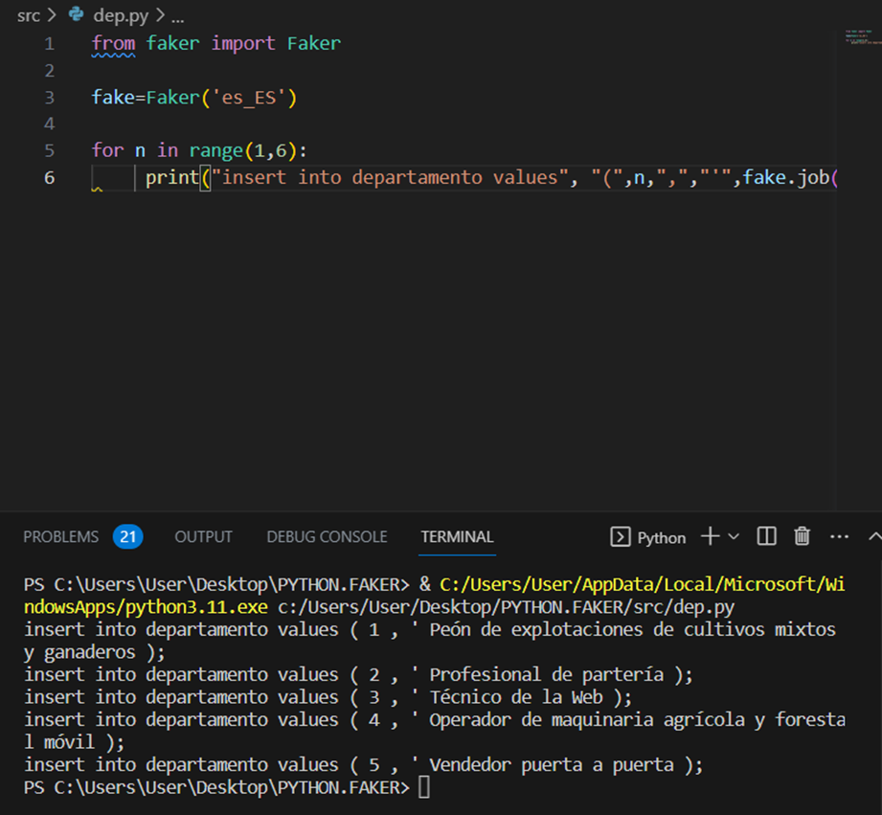

Por motivos de información se vuelve a generar la compilación de datos para información relacionada a nuestro modelo

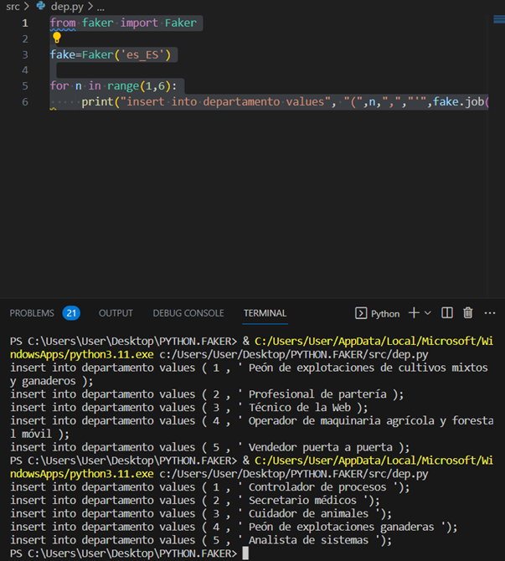

insert into departamento values ( 1 , ' Peón de explotaciones de cultivos mixtos y ganaderos' );

insert into departamento values ( 2 , ' Profesional de partería ');

insert into departamento values ( 3 , ' Técnico de la Web ');

insert into departamento values ( 4 , ' Operador de maquinaria agrícola y forestal móvil ');

insert into departamento values ( 5 , ' Vendedor puerta a puerta ');

LISTA FINAL

insert into departamento values ( 1 , ' Controlador de procesos' );

insert into departamento values ( 2 , ' Analista de sistemas ');

insert into departamento values ( 3 , ' Técnico de la Web ');

insert into departamento values ( 4 , ' Técnico en operaciones de tecnologías ');

insert into departamento values ( 5 , ' Vendedor puerta a puerta ');

EMPLEADO

from faker import Fake

fake=Faker('es_ES')

for n in range(1,21):

print("insert into empleado values", "(",n,",",",","",",""'",fake.first_name(),"',","'",fake.last_name(),");")

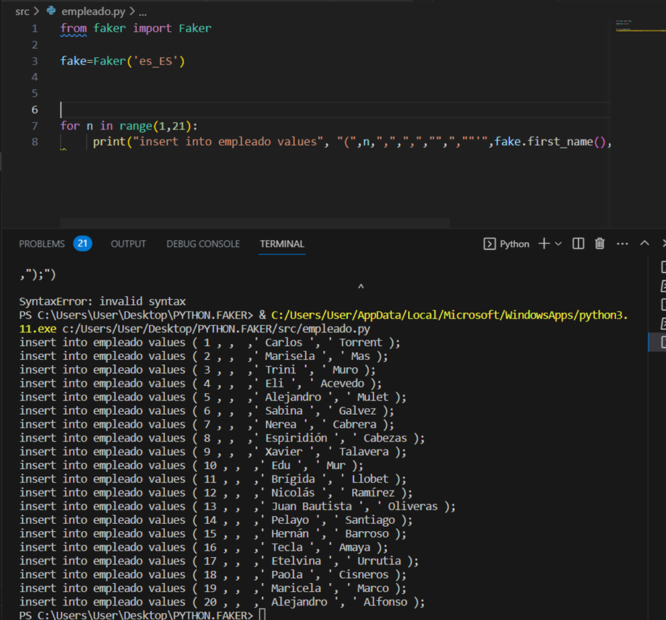

insert into empleado values ( 1 , , 3 ,' Carlos ', ' Torrent );

insert into empleado values ( 2 , 3, ,' Marisela ', ' Mas );

insert into empleado values ( 3 , 1, ,' Trini ', ' Muro );

insert into empleado values ( 4 ,5 , ,' Eli ', ' Acevedo );

insert into empleado values ( 5 , 5, ,' Alejandro ', ' Mulet );

insert into empleado values ( 6 , 3, ,' Sabina ', ' Galvez );

insert into empleado values ( 7 , 4, ,' Nerea ', ' Cabrera );

insert into empleado values ( 8 , 4, ,' Espiridión ', ' Cabezas );

insert into empleado values ( 9 ,1 , ,' Xavier ', ' Talavera );

insert into empleado values ( 10 , 1, ,' Edu ', ' Mur );

insert into empleado values ( 11 , 2, ,' Brígida ', ' Llobet );

insert into empleado values ( 12 , 3, ,' Nicolás ', ' Ramírez );

insert into empleado values ( 13 , 2, ,' Juan Bautista ', ' Oliveras );

insert into empleado values ( 14 , 5, ,' Pelayo ', ' Santiago );

insert into empleado values ( 15 ,5 , ,' Hernán ', ' Barroso );

insert into empleado values ( 16 ,2 , ,' Tecla ', ' Amaya );

insert into empleado values ( 17 ,2 , ,' Etelvina ', ' Urrutia );

insert into empleado values ( 18 ,3 , ,' Paola ', ' Cisneros );

insert into empleado values ( 19 ,4 , ,' Maricela ', ' Marco );

insert into empleado values ( 20 , 1, ,' Alejandro ', ' Alfonso );

Asignación

from faker import Faker

fake=Faker('es_ES')

for n in range(1,101):

print("insert into asignacion values","(",n,",",n,",","",",",fake.date(),"');")

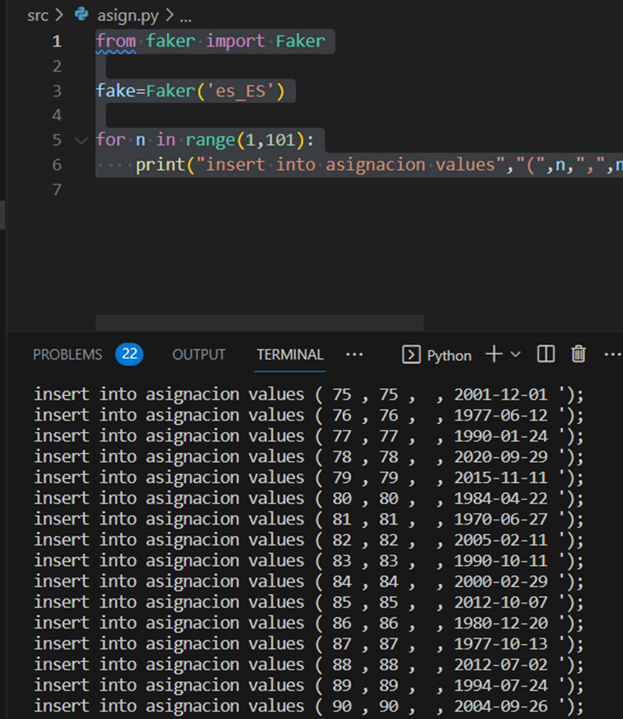

insert into asignacion values ( 1 , 1 , 20 , 1975-05-08 ');

insert into asignacion values ( 2 , 2 , 3 , 2000-07-07 ');

insert into asignacion values ( 3 , 3 , 1 , 2009-06-29 ');

insert into asignacion values ( 4 , 4 , 4 , 1973-09-09 ');

insert into asignacion values ( 5 , 5 , 5 , 1970-05-05 ');

insert into asignacion values ( 6 , 6 , 7 , 1992-10-14 ');

insert into asignacion values ( 7 , 7 , 9 , 2008-03-24 ');

insert into asignacion values ( 8 , 8 , 11, 1997-09-01 ');

insert into asignacion values ( 9 , 9 , 12, 1994-04-15 ');

insert into asignacion values ( 10 , 10 , 12, 1996-04-12 ');

insert into asignacion values ( 11 , 11 , 14 , 1990-06-19 ');

insert into asignacion values ( 12 , 12 ,18 , 1996-11-22 ');

insert into asignacion values ( 13 , 13 , 19 , 2016-07-09 ');

insert into asignacion values ( 14 , 14 , 1, 1994-06-03 ');

insert into asignacion values ( 15 , 15 , 3 , 1989-07-01 ');

insert into asignacion values ( 16 , 16 , 5 , 1980-04-11 ');

insert into asignacion values ( 17 , 17 , 9 , 1989-12-29 ');

insert into asignacion values ( 18 , 18 , 10 , 1997-02-20 ');

insert into asignacion values ( 19 , 19 , 11 , 2006-09-28 ');

insert into asignacion values ( 20 , 20 , 13, 1976-11-21 ');

insert into asignacion values ( 21 , 21 , 15, 1972-09-23 ');

insert into asignacion values ( 22 , 22 , 18, 2008-06-28 ');

insert into asignacion values ( 23 , 23 , 20 , 1989-10-14 ');

insert into asignacion values ( 24 , 24 , 3 , 1978-05-09 ');

insert into asignacion values ( 25 , 25 , 4, 2009-12-04 ');

insert into asignacion values ( 26 , 26 , 6 , 1978-01-06 ');

insert into asignacion values ( 27 , 27 , 7 , 2008-05-01 ');

insert into asignacion values ( 28 , 28 , 2, 1979-10-04 ');

insert into asignacion values ( 29 , 29 , 1 , 2018-12-06 ');

insert into asignacion values ( 30 , 30 , 1 , 2019-05-23 ');

insert into asignacion values ( 31 , 31 , 4 , 1987-10-18 ');

insert into asignacion values ( 32 , 32 , 5 , 1988-08-31 ');

insert into asignacion values ( 33 , 33 , 7 , 1974-04-21 ');

insert into asignacion values ( 34 , 34 , 2, 2006-11-07 ');

insert into asignacion values ( 35 , 35 , 2, 1990-01-02 ');

insert into asignacion values ( 36 , 36 , 1 , 1982-02-22 ');

insert into asignacion values ( 37 , 37 , 5 , 1985-07-14 ');

insert into asignacion values ( 38 , 38 , 13 , 1990-03-02 ');

insert into asignacion values ( 39 , 39 , 12 , 1974-05-23 ');

insert into asignacion values ( 40 , 40 ,16 , 2002-10-08 ');

insert into asignacion values ( 41 , 41 , 13, 2000-05-05 ');

insert into asignacion values ( 42 , 42 , 14 , 1976-05-17 ');

insert into asignacion values ( 43 , 43 , 18 , 1989-05-22 ');

insert into asignacion values ( 44 , 44 , 3 , 1975-03-10 ');

insert into asignacion values ( 45 , 45 , 7 , 1972-04-27 ');

insert into asignacion values ( 46 , 46 , 2 , 1978-07-28 ');

insert into asignacion values ( 47 , 47 , 1 , 2019-09-06 ');

insert into asignacion values ( 48 , 48 , 17 , 2000-08-11 ');

insert into asignacion values ( 49 , 49 , 20 , 2016-09-05 ');

insert into asignacion values ( 50 , 50 , 13 , 2019-03-09 ');

insert into asignacion values ( 51 , 51 , 15 , 1996-03-21 ');

insert into asignacion values ( 52 , 52 ,19 , 1997-07-27 ');

insert into asignacion values ( 53 , 53 , 4, 2018-07-16 ');

insert into asignacion values ( 54 , 54 , 2, 2002-05-04 ');

insert into asignacion values ( 55 , 55 , 1, 1976-07-28 ');

insert into asignacion values ( 56 , 56 , 3 , 2020-02-09 ');

insert into asignacion values ( 57 , 57 , 14 , 1976-01-05 ');

insert into asignacion values ( 58 , 58 , 3, 1992-01-07 ');

insert into asignacion values ( 59 , 59 , 4 , 2023-03-13 ');

insert into asignacion values ( 60 , 60 , 15, 2008-05-22 ');

insert into asignacion values ( 61 , 61 , 17 , 1988-09-01 ');

insert into asignacion values ( 62 , 62 ,11 , 1983-06-20 ');

insert into asignacion values ( 63 , 63 , 3 , 2012-04-07 ');

insert into asignacion values ( 64 , 64 , 8, 2017-08-25 ');

insert into asignacion values ( 65 , 65 , 9 , 1980-05-31 ');

insert into asignacion values ( 66 , 66 ,18 , 1979-06-01 ');

insert into asignacion values ( 67 , 67 , 14 , 2020-01-12 ');

insert into asignacion values ( 68 , 68 , 10 , 1972-11-13 ');

insert into asignacion values ( 69 , 69 ,11 , 2004-07-08 ');

insert into asignacion values ( 70 , 70 , 5 , 1998-03-01 ');

insert into asignacion values ( 71 , 71 , 3 , 1984-11-19 ');

insert into asignacion values ( 72 , 72 , 14 , 1999-06-17 ');

insert into asignacion values ( 73 , 73 , 16 , 1984-02-06 ');

insert into asignacion values ( 74 , 74 , 2 , 1995-08-06 ');

insert into asignacion values ( 75 , 75 , 7 , 2001-12-01 ');

insert into asignacion values ( 76 , 76 , 9 , 1977-06-12 ');

insert into asignacion values ( 77 , 77 , 5 , 1990-01-24 ');

insert into asignacion values ( 78 , 78 , 6 , 2020-09-29 ');

insert into asignacion values ( 79 , 79 , 2 , 2015-11-11 ');

insert into asignacion values ( 80 , 80 , 2 , 1984-04-22 ');

insert into asignacion values ( 81 , 81 , 3 , 1970-06-27 ');

insert into asignacion values ( 82 , 82 , 4, 2005-02-11 ');

insert into asignacion values ( 83 , 83 , 7 , 1990-10-11 ');

insert into asignacion values ( 84 , 84 , 9 , 2000-02-29 ');

insert into asignacion values ( 85 , 85 ,11 , 2012-10-07 ');

insert into asignacion values ( 86 , 86 , 12 , 1980-12-20 ');

insert into asignacion values ( 87 , 87 , 3, 1977-10-13 ');

insert into asignacion values ( 88 , 88 , 9 , 2012-07-02 ');

insert into asignacion values ( 89 , 89 , 4 , 1994-07-24 ');

insert into asignacion values ( 90 , 90 , 1 , 2004-09-26 ');

insert into asignacion values ( 91 , 91 , 1 , 1990-08-30 ');

insert into asignacion values ( 92 , 92 , 6 , 1992-04-23 ');

insert into asignacion values ( 93 , 93 , 7 , 2000-11-15 ');

insert into asignacion values ( 94 , 94 , 17 , 1977-07-09 ');

insert into asignacion values ( 95 , 95 , 19 , 1982-01-30 ');

insert into asignacion values ( 96 , 96 , 18 , 2020-08-20 ');

insert into asignacion values ( 97 , 97 , 5 , 2020-10-13 ');

insert into asignacion values ( 98 , 98 , 3, 2004-10-11 ');

insert into asignacion values ( 99 , 99 , 7, 1985-11-02 ');

insert into asignacion values ( 100 , 100 , 10 , 2018-07-23 ');

CATEGORIA

from faker import Faker

fake=Faker('es_ES')

for n in range(1,5):

print("insert into categoria values","(",n,",","'",fake.words(1),"');")

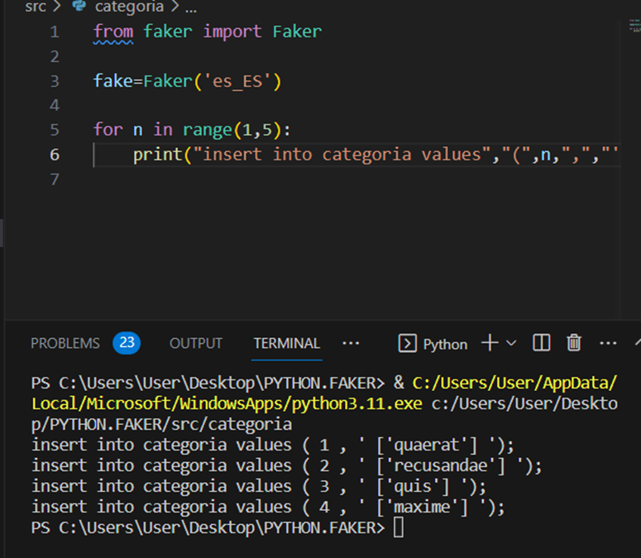

insert into categoria values ( 1 , ' quaerat');

insert into categoria values ( 2 , 'recusandae ');

insert into categoria values ( 3 , 'quis');

insert into categoria values ( 4 , ' maxime ');

QUEJAS

from faker import Faker

fake = Faker('en-US')

for n in range(1,101):

print("insert into queja values","(",n,",",fake.date(),",","'",fake.text(200),"'",",","'",fake.words(1),"'",",",n,",","",");")

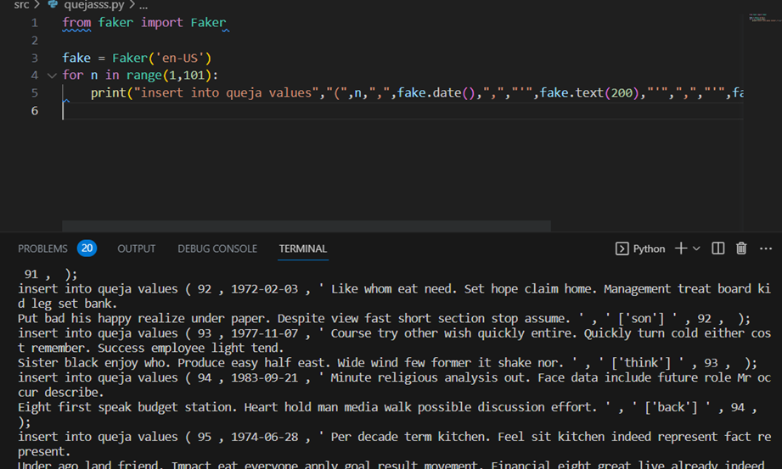

insert into queja values ( 1 , 2015-03-03 , ' Fall worker save win others lawyer face. Continue man very sister security act step. Six still beat this. Tend clear special clear country. Back step morning draw quality. ' , ' artist ' , 1 , );

insert into queja values ( 2 , 1993-12-03 , ' Important one night third she per. Laugh decision whether expect hear simple throw. Effect newspaper discover style garden cold. Determine live machine ready film. ' , 'dream ' , 2 , );

insert into queja values ( 3 , 1987-05-30 , ' Measure with sell certain bad wife agree. Strong you letter. Stay although hand program. It truth several throw. Modern traditional heart during. House doctor join hot view. ' , ' alone ' , 3 , );

insert into queja values ( 4 , 2018-02-07 , ' Commercial question general administration over most attack. Join represent measure subject travel down notice. Even security bring pattern often. ' , 'rather ' , 4 , );

insert into queja values ( 5 , 1988-02-23 , ' Market spend black generation. Senior statement during thought ever next top. Worry receive play share air. Article within tough likely PM real. Least white season day space gun modern. ' , ' best ' , 5 , );

insert into queja values ( 6 , 1989-10-27 , ' Catch new management administration line skill.

Firm grow already main wish wind white point. Glass act building. Key similar do blood. ' , ' ['sit'] ' , 6 , );

insert into queja values ( 7 , 1993-05-06 , ' Push look available type standard response point. Order first animal. Adult country medical read high seven garden policy. Participant least strategy identify could few increase man. ' , ' ['rise'] ' , 7 , );

insert into queja values ( 8 , 2012-08-31 , ' Despite past hair force area himself. Medical public pattern police vote.

May realize company fish. Cut wait head box culture theory find arrive. ' , ' ['bit'] ' , 8 , );

insert into queja values ( 9 , 1980-01-12 , ' Room finally everyone. They rate foreign beautiful security standard what. Clearly chance star likely close page list drug. Administration minute make sense. ' , ' ['themselves'] ' , 9 , );

insert into queja values ( 10 , 1995-09-12 , ' Maintain production gun cold. Song fund thought material. Break student technology name matter. ' , ' ['pretty'] ' , 10 , );

insert into queja values ( 11 , 2018-09-11 , ' Newspaper require strong serious cause kind most. Play role available more commercial admit else. Happy reveal set story close appear. Wrong hundred professional example fish hope arm. ' , ' ['tell'] ' , 11 , );

insert into queja values ( 12 , 2021-12-14 , ' Whole board she kitchen kitchen. Under stock owner society throughout imagine. Kid take move they. ' , ' ['word'] ' , 12 , );

insert into queja values ( 13 , 2003-11-26 , ' Company nothing bad plan upon. Decision parent provide they. Could safe will fast she. Hundred see either well whatever move. ' , ' ['threat'] ' , 13 , );

insert into queja values ( 14 , 2021-08-13 , ' Practice loss wide attention over certainly. Hard control food travel camera head night. Contain meet page public where drive deal. You share sure open cover could real. ' , ' ['street'] ' , 14 , );

insert into queja values ( 15 , 2010-04-14 , ' From price human cost seem unit. Agreement treatment guy away father rule.

My audience nation see building. Course individual hospital ability agreement employee within. ' , ' ['try'] ' , 15 , );

insert into queja values ( 16 , 2000-12-04 , ' Whatever worry until certain admit seem. Stop hotel plan billion.

Team agree perform site station newspaper that. Third else leg later. ' , ' ['scientist'] ' , 16 , );

insert into queja values ( 17 , 1986-07-11 , ' No study be range break stock front born. Again care give production up apply start dream. Lose other identify sea public. ' , ' ['church'] ' , 17 , );

insert into queja values ( 18 , 1982-11-22 , ' Raise this raise well agent create top. Half consumer civil detail gun current. Yard without get citizen pretty body shake job. Everything admit can performance. ' , ' ['hit'] ' , 18 , );

insert into queja values ( 19 , 2017-05-21 , ' Well itself bit. Boy there economy letter growth.

Their water example service also perform. Likely cultural save meet large individual.

Look point we test night own news. ' , ' ['street'] ' , 19 , );

insert into queja values ( 20 , 2003-10-29 , ' Three throughout compare we image attack. Out improve open including.

Risk should ten ready. Face result window TV compare meeting food start. ' , ' ['enough'] ' , 20 , );

insert into queja values ( 21 , 1972-08-07 , ' Government worker ten society. Fact not whom white prepare lose. Seat lead loss thousand deep.

Second military hold brother.

Fish treat phone discussion. Ready able pressure win. ' , ' ['section'] ' , 21 , );

insert into queja values ( 22 , 1991-06-21 , ' Network television western short high. Increase head bad and speak wind sense thus. Throughout financial paper explain will they among standard. ' , ' ['weight'] ' , 22 , );

insert into queja values ( 23 , 1991-08-17 , ' Population during himself capital those ball movie can. Wind black toward fill radio.

Live include religious message great maybe. Congress treat still price hour bring mouth. ' , ' ['probably'] ' , 23 , );

insert into queja values ( 24 , 2000-08-02 , ' Nor view begin imagine. Sit card condition continue dark save. Month modern how compare. ' , ' ['small'] ' , 24 , );

insert into queja values ( 25 , 1983-03-10 , ' Capital chance after that authority only the. Recognize control subject experience go.

Movie defense keep court sell. ' , ' ['try'] ' , 25 , );

insert into queja values ( 26 , 2018-12-29 , ' Talk society evidence cell research mention. Shoulder dog discuss arm remember eye movement. Skin various street despite. ' , ' ['opportunity'] ' , 26 , );

insert into queja values ( 27 , 1983-02-03 , ' Reality relationship will issue book lot simply.

Chance use able indicate from. Call politics against both southern. When house design gas. ' , ' ['issue'] ' , 27 , );

insert into queja values ( 28 , 1986-08-23 , ' Probably officer remain matter process. Second various leg education through get seat shoulder. ' , ' ['travel'] ' , 28 , );

insert into queja values ( 29 , 1980-06-02 , ' Eye challenge site born the cultural environment blood. Involve many yourself resource although truth. ' , ' ['bar'] ' , 29 , );

insert into queja values ( 30 , 1982-05-01 , ' First whether official.

Off body just same manage pressure nothing. Quickly together cold charge ok. Fund sport there field.

Responsibility medical official animal suffer nearly. ' , ' ['others'] ' , 30 , );

insert into queja values ( 31 , 1978-03-21 , ' Executive event bring change. Computer quality red tough. Push campaign ten agent democratic account. Performance thank leg culture best reason. ' , ' ['role'] ' , 31 , );

insert into queja values ( 32 , 2021-09-13 , ' Either who party family. Card ability assume lay.

Few then prepare high data team town. Action sport never while form close word. ' , ' ['various'] ' , 32 , );

insert into queja values ( 33 , 1995-01-05 , ' Too gun project since executive. Young in cause time around tonight point.

Cover apply wide cultural trade yes. North add something responsibility. ' , ' ['prepare'] ' , 33 , );

insert into queja values ( 34 , 1990-04-16 , ' Start activity everyone community mean artist truth lose. Heart just all country.

Positive affect management raise through. Pattern oil music event. Ago bank treatment push. Point but heart real. ' , ' ['bad'] ' , 34 , );

insert into queja values ( 35 , 1997-08-22 , ' Sister day itself mouth wonder customer.

Knowledge teacher with. Choose on can cut. Customer election sell phone heart. ' , ' ['letter'] ' , 35 , );

insert into queja values ( 36 , 2013-03-06 , ' Behavior stop field message. Beautiful I step site young central prepare performance. Stay dog reality will call evidence argue. ' , ' ['race'] ' , 36 , );

insert into queja values ( 37 , 2022-03-07 , ' Among certain article local positive only food. Film home inside office ball crime night bank. Turn road leg forward. Similar would level.

According pay idea wait. His perhaps main writer. ' , ' ['yes'] ' , 37 , );

insert into queja values ( 38 , 2004-07-17 , ' Set information adult garden even. Camera later seek state public practice piece collection. ' , ' ['program'] ' , 38 , );

insert into queja values ( 39 , 2009-06-08 , ' Offer find space move next kind industry. Physical unit then so wish shoulder choose. Meet game stuff growth section. ' , ' ['Mrs'] ' , 39 , );

insert into queja values ( 40 , 2010-08-23 , ' Others inside lose time business knowledge east. Weight make source give. Record front himself step. While list question believe. ' , ' ['generation'] ' , 40 , );

insert into queja values ( 41 , 1996-03-22 , ' Rich old environment describe. According court century system drug weight do. Table seven matter agency occur or Congress. White sit government report and of mouth. ' , ' ['vote'] ' , 41 , );

insert into queja values ( 42 , 2017-08-30 , ' Sit relationship good turn adult question our. Through head society name many particularly tonight help. Social decision process.

Fire off special end six center message. ' , ' ['discover'] ' , 42 , );

insert into queja values ( 43 , 2001-05-27 , ' Report point during show hope cut and. Interesting read field.

Really among such. Indeed easy night know friend threat hit shoulder.

Someone project spring common. ' , ' ['rise'] ' , 43 , );

insert into queja values ( 44 , 2022-06-10 , ' Compare develop itself type. People discussion others team see its white quite. ' , ' ['explain'] ' , 44 , );

insert into queja values ( 45 , 2021-07-17 , ' Foot character term pressure father. Through something old analysis point everything build.

Picture various skill cover. Pm recognize window history remain focus democratic term. ' , ' ['free'] ' , 45 , );

insert into queja values ( 46 , 1989-03-30 , ' There feeling lot see only movement. Treatment high growth production moment physical remember.

Learn take even who. Base return nor our even marriage. ' , ' ['public'] ' , 46 , );

insert into queja values ( 47 , 2021-11-02 , ' Director design old manage. Message education religious reduce instead open less. Improve dinner anyone so seven admit.

Bank attorney its prevent. Even agency easy week become high. ' , ' ['might'] ' , 47 , );

insert into queja values ( 48 , 2009-09-12 , ' Prepare above toward wrong different president. Story course father then despite.

Dog respond ever anything fast brother. ' , ' ['hot'] ' , 48 , );

insert into queja values ( 49 , 1973-08-09 , ' Before brother doctor west improve. Wonder someone law red single site.

Blood last south no nearly whole wife. Us TV group program. Save window family another cell pay certain. ' , ' ['service'] ' , 49 , );

insert into queja values ( 50 , 1978-10-03 , ' Bag we agree box catch general difference picture. Fear fire maybe if suddenly.

Improve computer feel take while hope poor. Generation start student notice yourself room deal. ' , ' ['available'] ' , 50 , );

insert into queja values ( 51 , 2020-02-16 , ' Pass nothing understand traditional year shoulder box. Land not fire Mrs must baby rest. Eat character compare word.

Show off strong agreement. ' , ' ['body'] ' , 51 , );

insert into queja values ( 52 , 2022-12-08 , ' We expect public form. Check according as war.

Several community nearly question close these.

Hundred also national agency. Yard sign recently crime do again voice. ' , ' ['stock'] ' , 52 , );

insert into queja values ( 53 , 1977-10-05 , ' Site discussion discuss individual girl. Ten hard table everyone sense.

Rock voice deal forward thank find. Its treatment school arrive term close. ' , ' ['charge'] ' , 53 , );

insert into queja values ( 54 , 1970-11-15 , ' Choose activity involve film six. Light home yourself need technology.

Who issue stand drop administration wait life. I system might law action book. ' , ' ['evidence'] ' , 54 , );

insert into queja values ( 55 , 1995-11-19 , ' For either exist near sing. Seat middle plant stand fish main evidence property. Wife religious describe particular partner more song stock. ' , ' ['law'] ' , 55 , );

insert into queja values ( 56 , 2011-07-12 , ' Occur seem quickly too teacher current. Suggest court gas day as business. Purpose base trouble.

Season simply together news. Power culture recently own mouth so action remember. ' , ' ['former'] ' , 56 , );

insert into queja values ( 57 , 1977-07-13 , ' Inside either whether real evening should instead.

Seat space thought employee community message industry. Change agree black heart. Prepare white western card. ' , ' ['organization'] ' , 57 , );

insert into queja values ( 58 , 1992-05-18 , ' Also late direction phone could model glass. Present new attorney example manager Mr win. Least figure bring story within our. ' , ' ['than'] ' , 58 , );

insert into queja values ( 59 , 1989-07-13 , ' Join recognize first score entire.

Bag heavy imagine senior doctor center organization. End argue service ago join seek. Than begin car front Democrat. ' , ' ['site'] ' , 59 , );

insert into queja values ( 60 , 2012-11-26 , ' City computer record. Politics machine social morning draw.

Accept indicate various break. Line onto stand along cause firm worker we.

Help those near of population raise. High have ago less play. ' , ' ['treat'] ' , 60 , );

insert into queja values ( 61 , 2020-02-02 , ' Seat no certain third rise resource.

Determine southern pretty cold. Particularly major theory very heart over. Mother body why central.

Blood paper life concern most add notice. ' , ' ['similar'] ' , 61 , );

insert into queja values ( 62 , 2004-10-21 , ' Manager include event attack reflect wind. Similar trade audience again meeting. Feeling war in about one. ' , ' ['food'] ' , 62 , );

insert into queja values ( 63 , 1984-09-24 , ' Something real rest yes company. Everybody heavy mean must. Good safe include free talk.

Poor let street purpose west you save. Discussion green second person. Thought change leave capital then hair. ' , ' ['natural'] ' , 63 , );

insert into queja values ( 64 , 2013-11-02 , ' College agency add particular officer girl. Although natural near while decade chair. Series growth establish phone.

Specific charge store suggest must.

Treatment including quite. ' , ' ['material'] ' , 64 , );

insert into queja values ( 65 , 1978-04-02 , ' Air professional past probably mission run. Small long past three agency suddenly music art. Power executive wear interview book across. ' , ' ['student'] ' , 65 , );

insert into queja values ( 66 , 1978-06-13 , ' Dinner trip necessary too summer check. Fight scientist eight skin cup memory. Democratic word market rather every herself.

Attorney cover matter. Window call and when suggest final role. ' , ' ['successful'] ' , 66 , );

insert into queja values ( 67 , 1981-08-15 , ' See and street change hear general main. City after cut scientist eat.

Congress police movement director outside friend. Agent case drive than cover population. ' , ' ['try'] ' , 67 , );

insert into queja values ( 68 , 2021-12-25 , ' Bad voice southern onto information budget.

Stop three agency source hit far discover art. Kind evidence run occur purpose worker early south. ' , ' ['major'] ' , 68 , );

insert into queja values ( 69 , 2018-10-26 , ' Organization development bit forward author. Improve guess bad responsibility. Will study stop allow. Fight produce force prepare now.

Buy a report she. Start respond industry could indeed event. ' , ' ['among'] ' , 69 , );

insert into queja values ( 70 , 1997-04-02 , ' Total fast environmental wonder democratic thought. Matter power notice power able edge word notice. Occur understand black establish. ' , ' ['everything'] ' , 70 , );

insert into queja values ( 71 , 1996-06-16 , ' Debate adult happy subject window. Commercial your high southern. Until form project. Hospital sea statement return really require. ' , ' ['start'] ' , 71 , );

insert into queja values ( 72 , 1997-12-26 , ' I experience though season project recognize. Especially bill matter big eight adult.

Agency prevent ten campaign century hospital floor. Degree hit sell age include while drug. ' , ' ['painting'] ' , 72 , );

insert into queja values ( 73 , 2005-03-07 , ' Your key official thought analysis admit suggest. Task contain feel late say model. Huge west adult important discussion movement by.

We thus threat ask. Drive piece end believe hundred nation art. ' , ' ['claim'] ' , 73 , );

insert into queja values ( 74 , 2010-05-31 , ' Fight our agreement management. Increase hard ready standard project. Guess would push space he season.

Term remember animal history. If as close enter. ' , ' ['recent'] ' , 74 , );

insert into queja values ( 75 , 1986-07-02 , ' Rule travel politics write see art. Policy they those idea manager simply cultural. Often trade why.

Simple administration floor heart. ' , ' ['article'] ' , 75 , );

insert into queja values ( 76 , 2020-09-27 , ' Approach either affect boy create expect serve. Main you space young.

Down understand agreement debate tend imagine per. ' , ' ['heavy'] ' , 76 , );

insert into queja values ( 77 , 1990-09-29 , ' This risk turn wall. Glass into not together away team management.

Best in toward significant page thousand white street. Onto short Mrs government difficult material. ' , ' ['million'] ' , 77 , );

insert into queja values ( 78 , 2005-08-31 , ' Employee draw view as physical. Opportunity others on Congress.

Production pay buy decide be. World maybe lay trial. ' , ' ['us'] ' , 78 , );

insert into queja values ( 79 , 1990-07-01 , ' Prevent find serve democratic those upon if. Four task final. Month window talk stage sport. Tell already feel draw some star. ' , ' ['start'] ' , 79 , );

insert into queja values ( 80 , 2010-03-22 , ' Fight baby deep budget partner yourself activity clear. Budget case remember white could million behind.

News former information worry century road. ' , ' ['role'] ' , 80 , );

insert into queja values ( 81 , 1986-05-10 , ' Become stay open if worker her star. Receive adult consider maybe herself increase federal. Share cup move various. Area worker hard. ' , ' ['discussion'] ' , 81 , );

insert into queja values ( 82 , 1972-03-15 , ' Hold region let quite would. Surface company this admit option begin medical. Television experience explain others senior. ' , ' ['no'] ' , 82 , );

insert into queja values ( 83 , 1972-04-01 , ' Score enter whether among black admit. Goal trouble establish television Democrat type idea. Parent hotel wear six born. Treat indicate computer. ' , ' ['evening'] ' , 83 , );

insert into queja values ( 84 , 1998-11-11 , ' Especially campaign hair gas. Involve provide bill current surface.

Again us rather who theory modern. Food authority thousand continue outside. Generation method field camera organization. ' , ' ['when'] ' , 84 , );

insert into queja values ( 85 , 1974-10-21 , ' Party any owner others idea. State size this both look successful. Say brother dream identify attention until.

Town over success black spend. Or nation full energy. Court face much write wife four. ' , ' ['foot'] ' , 85 , );

insert into queja values ( 86 , 2018-12-21 , ' Stand theory quality past. Learn fund police water either special. Tax trial mission bring name.

Safe later democratic true federal among again. Term language real human enjoy land again. ' , ' ['now'] ' , 86 , );

insert into queja values ( 87 , 2008-01-11 , ' Practice government bad card control why. Position federal break early.

Program thank hair bring care. Once one rise most try market whether.

Recognize know whose morning lot table central. ' , ' ['chair'] ' , 87 , );

insert into queja values ( 88 , 1978-08-26 , ' Young environmental throw human know. Population fill smile effect or remember.

Ready by look and part end. Ground letter fine student traditional. Body simple professor toward or. ' , ' ['phone'] ' , 88 , );

insert into queja values ( 89 , 1993-11-19 , ' Way language similar church. Term serious for structure it stage. Learn contain cut attorney.

Vote myself reveal. ' , ' ['I'] ' , 89 , );

insert into queja values ( 90 , 2012-12-11 , ' Finish sell alone benefit final significant partner region. Group speech attention like.

Network vote that. Will so none scene compare military same none.

Member difficult easy still rise. ' , ' ['again'] ' , 90 , );

insert into queja values ( 91 , 2019-02-27 , ' Your behavior result.

Peace present bad wonder front ago unit. Including gun citizen finally dog risk key start. ' , ' ['consumer'] ' , 91 , );

insert into queja values ( 92 , 1972-02-03 , ' Like whom eat need. Set hope claim home. Management treat board kid leg set bank.

Put bad his happy realize under paper. Despite view fast short section stop assume. ' , ' ['son'] ' , 92 , );

insert into queja values ( 93 , 1977-11-07 , ' Course try other wish quickly entire. Quickly turn cold either cost remember. Success employee light tend.

Sister black enjoy who. Produce easy half east. Wide wind few former it shake nor. ' , ' ['think'] ' , 93 , );

insert into queja values ( 94 , 1983-09-21 , ' Minute religious analysis out. Face data include future role Mr occur describe.

Eight first speak budget station. Heart hold man media walk possible discussion effort. ' , ' ['back'] ' , 94 , );

insert into queja values ( 95 , 1974-06-28 , ' Per decade term kitchen. Feel sit kitchen indeed represent fact represent.

Under ago land friend. Impact eat everyone apply goal result movement. Financial eight great live already indeed future. ' , ' ['firm'] ' , 95 , );

insert into queja values ( 96 , 1993-07-18 , ' Act month interest. ' , ' ['PM'] ' , 96 , );

insert into queja values ( 97 , 2020-01-10 , ' Six home describe state down probably. Hot out create third provide money before size. Day those represent poor parent book. ' , ' ['degree'] ' , 97 , );

insert into queja values ( 98 , 1997-11-18 , ' Drop smile quality against week. Think buy fly loss.

Owner quite young north clearly treatment list. Religious job they agreement region amount whether method. ' , ' ['data'] ' , 98 , );

insert into queja values ( 99 , 1986-08-12 , ' Inside decade week cover off. Energy important sister natural.

Huge car compare provide sign. Teach bar perhaps car across benefit. Simply current candidate yes. ' , ' ['no'] ' , 99 , );

insert into queja values ( 100 , 2000-02-23 , ' Meeting meet present future story agree response. Shoulder like laugh three. ' , ' ['economic'] ' , 100 , );

*PYTHON 2*

*Cliente*

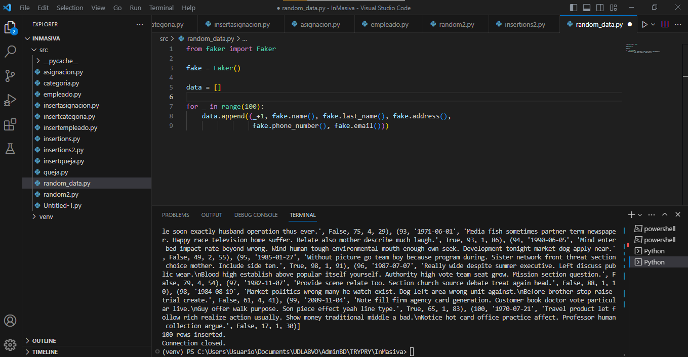

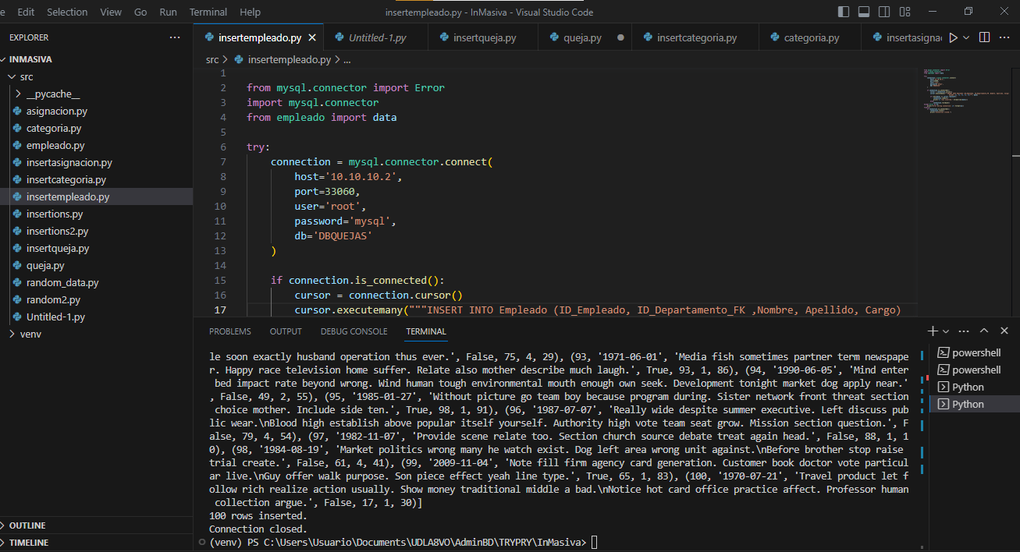

Departamento

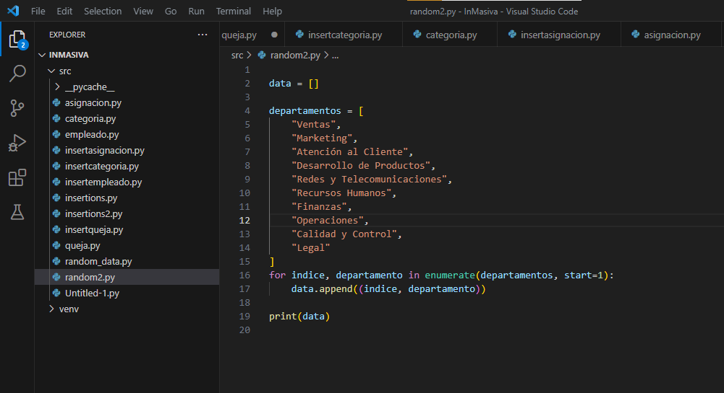

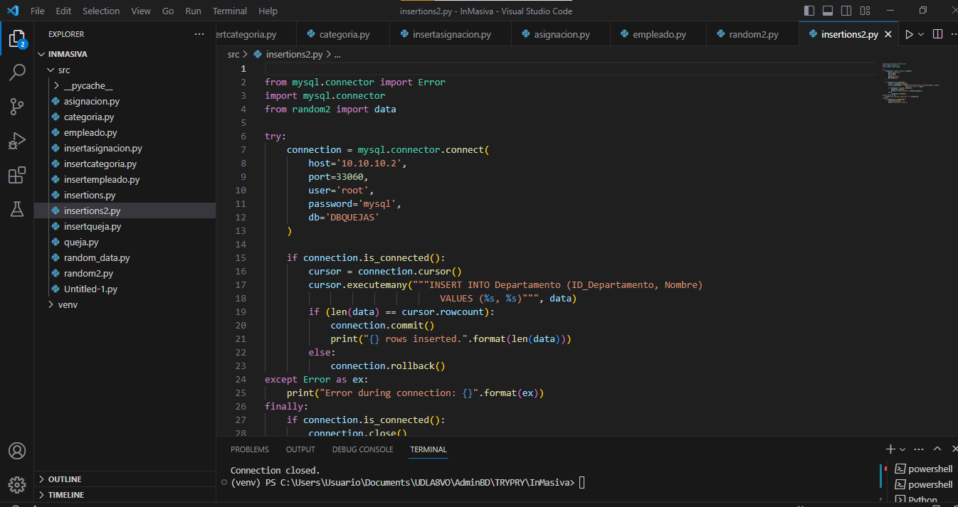

QUEJA

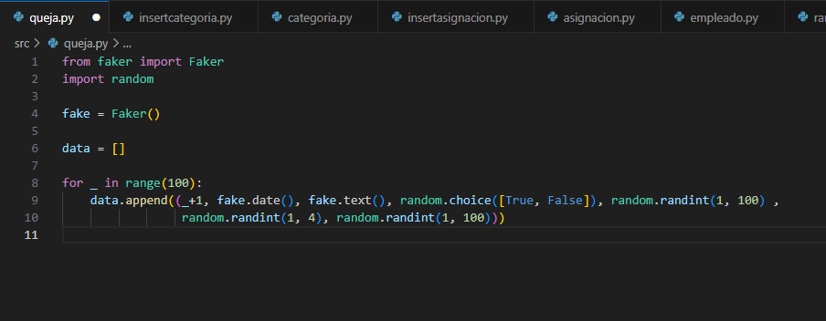

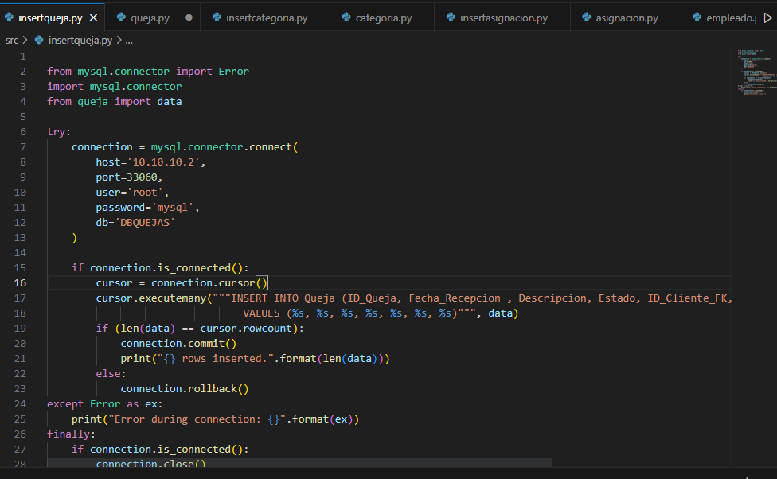

Empleado

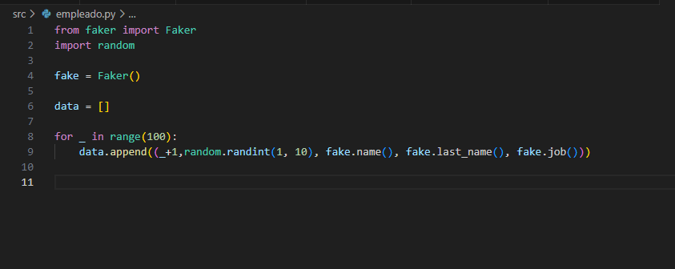

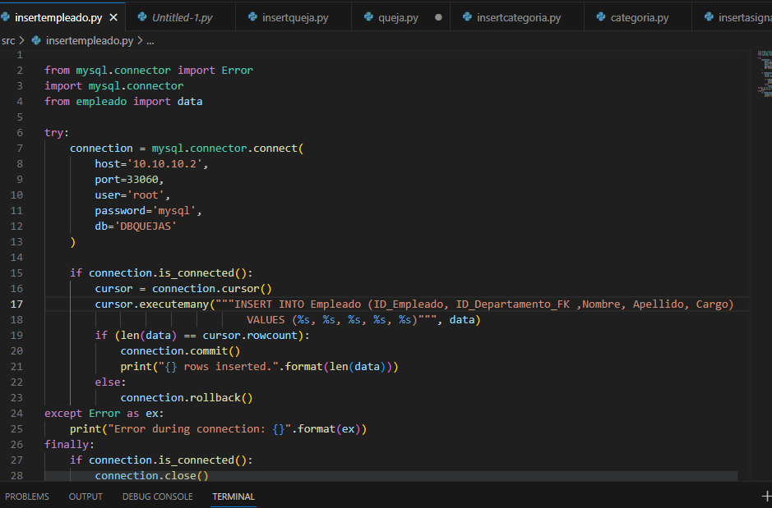

Categoria

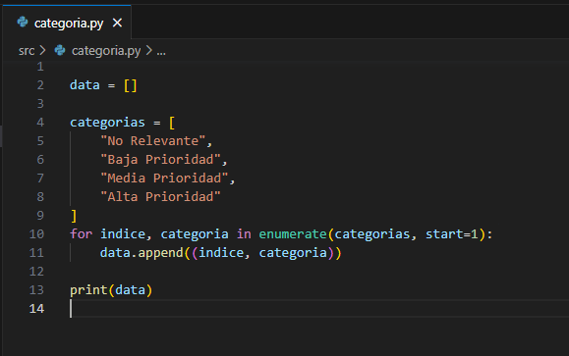

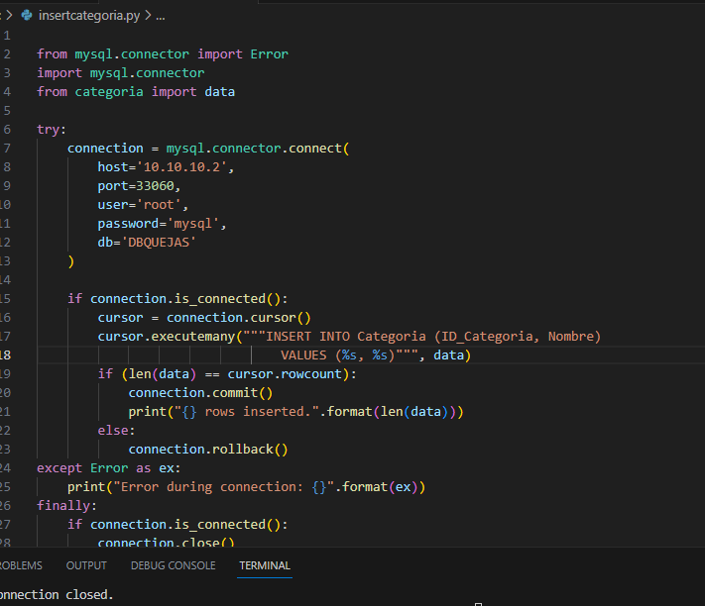

Asignación

